**Lab # 06**

**Objective: To learn RMI-IIOP**

* Create RMI IIOP application in which take a sentence at runtime on the client application and let the server return its reverse.  
  E.g. input could be: subject is distributed computing   
  output should be: computing distributed is subject.

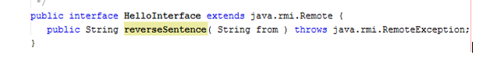

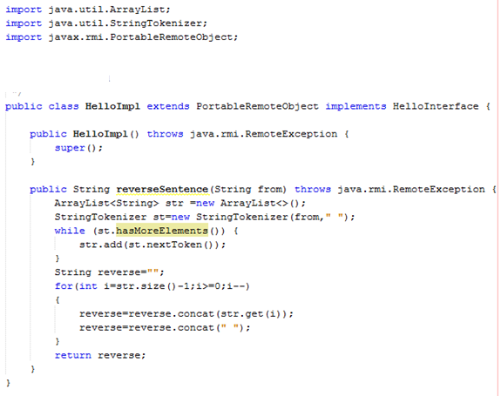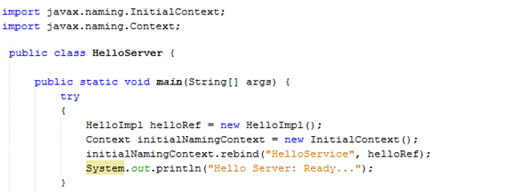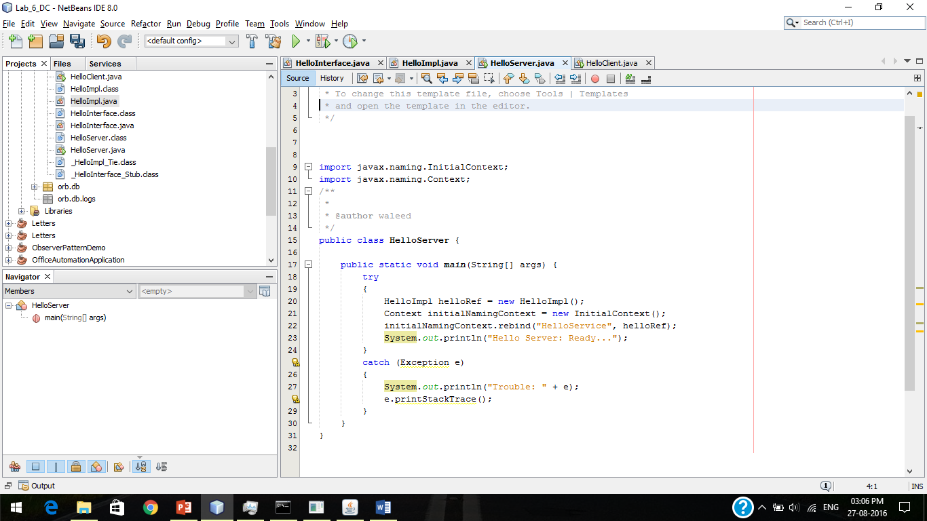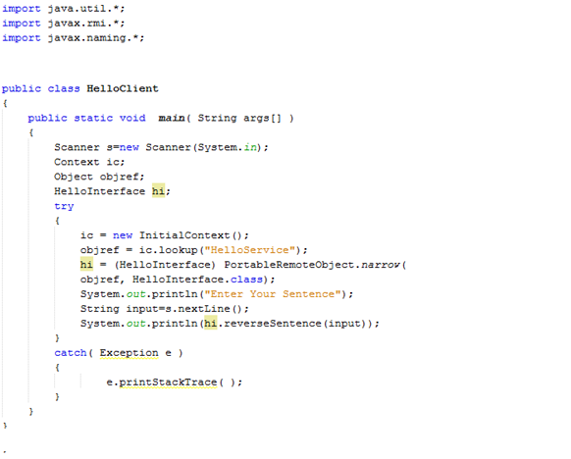

Output

